Ills of self-medication

Arpita Kashyap Khushboo Sharma Amanpreet Singh

# **Abstract**

Self-medication is a widespread practice in which people self-administer treatment for medical or mental illnesses by using drugs or outside influences. Dietary supplements and over-the-counter medications are common forms of self-medication. Authorities are concerned about this worldwide issue. Without medical supervision, irrational antimicrobial usage can result in improper therapy, missed diagnoses, treatment delays, pathogen resistance, and elevated morbidity. Serious side effects include antibiotic resistance, skin issues, hypersensitivity, and allergies might result from ignorance of dosage, timing, and side effects. Responses to surveys shed light on this problem

# I. Introduction

The word self-medication refers to the practice of consuming any foreign substance without a proper guideline or usage instruction at the moment, in the idea of a self-administered treatment. For instance, when a doctor is not available to be contacted by, the patient can use his/her previous knowledge to figure out his/her current medical situation and a medical situation can be aimed at being controlled. Only after a proper examination can the disease or medical condition of the individual be confirmed, and appropriate medical treatment be decided. To add on to the experiences of self-medication in India, the behavioral aspects of the medical personnel should also be pointed too. This can be extrapolated to the fact that irrespective of the disease or severity of it, the doctors are expected to treat the patient. The risks of this turning into a serious situation should be well examined by the doctors who advice the patients to opt for over the counter drugs in case of a similar medical situation next time. A lot of such situations can be imagined with a pragmatic approach and the said statement can be justified. The matter of concern is to minimize, and hence eliminate the ills of self-medication. Such a system can only be developed by an active participant of all the medical personnel and consumers/patients. Only after a proper examination can the disease or medical condition of the individual be confirmed, and appropriate medical treatment be decided

# II. Literature Survey

**1.C Bradley A. Blenkinsopp "Over the counter drugs: the future for self** [1]

The research done in this paper focuses all about the sale and purchase of the over-the-counter drugs and the ways to minimize it. This involves a number of initiatives primarily on the doctor’s end and the pharmacist’s end. The medical faculty working together are aiming to curb this problem. But the authors undermine the fact that there can be multiple sources of self-medication, multiple reasons for self-medication, and hence leading us to fight against a broader scope of self-medication than assumed. Also, not all times self-medication provides individuals with a good result. So, the authors lack their research into

the effects of self-medication on different patients.

**2.The role of the pharmacist in self care and self medication. Report of the 4th WHO consultative group on the role**

**of the pharmacist" The Hague 1998 [online]** [2]

The research paper pays all its attention to the role of the pharmacist in supporting and mitigating self-medication. The authors state the outcomes of the four meetings held under the supervision of WHO. They focus on the fact that in order to abate the ill-effects and harms of self-medication, the pharmacists should be well trained to check with the usage and requirements of the medicines. This anyhow proves beneficiary in helping the common masses to understand the usage and requirements of medicines, but due to lack of knowledge in a lot of places and increasing sources of self-medication, it is not wise to think of this as the only way to help people out. It does not focus on the effects caused by self-medication in the past or might cause in the future.

**3.JA Pagane S Ross J Yaw D. Polsky "Self medication and health insurance coverage in Mexico" Health Policy vol. 75 pp. 170-177 2007.** [3]

This research paper focuses on the effects of self-medication on nursing students, narrowing their scope to a specific age group and specific routine. However, the real challenge lies in the issues to be dealt with the pastorals and people lacking knowledge. Also, people studying/practicing nursing are still well aware of the medicines they take by themselves. Also, there is not much of the research that has been done on figuring out the most followed reasons leading to self-medication. This research also does not inform us about the success rate observed as a result of self-medication.

**4.WHO guidelines for the regulatory assessment of medicinal products for use in self medication 2000 [online]** [4]

This research has a different perspective towards self-medication. It lays down different techniques and ways to regulate self-medication. The project helps the common masses to know about the prescription and the validity of the medicines. It does not tell us about the adverse effects of self-medication and does not discuss the causes of self-medication. Also, it can be indirectly noted that this project supports self-medication by regulating it.

**5. EVALUATION of the Knowledge, Attitude and Practice of Self-Medication among First-Year Medical Students 5. - Med Princ Pract 2006; 15:270–275** [5]

This research is the most valid and appropriate one according to the needs and purpose of the project taken in hand. It focuses on the knowledge, attitude and practice of self-medication. It takes the data from the students studying in the first year, and then classifies it according to various norms. This provides a very substantial basis for the categorization and interpretation of the results. But it does not focus on the causes and experiences leading to the practice of self-medication.

**ARCHITECTURE**

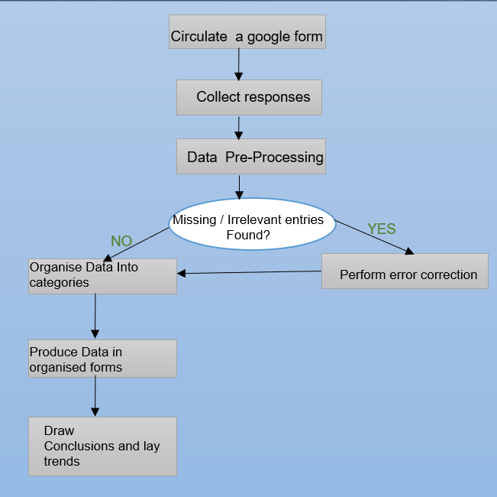

### MODULES

# **Module 1: DATA UNDERSTANDING AND COLLECTION**

First module has two agendas – Firstly, it involves business understanding regarding the potential use and need for this research. Industry experts and students pursuing careers in the fields affected by self-medication were asked for advice regarding the viability of this research and about the possible findings that would change the current techniques for the better.

Secondly, the type and range of target data set was defined and a self-administered open and closed ended questionnaire was formed to collect data. Over a range of 3 months from August to October for people from different age groups, gender and culture. It involved questions about preference for self-medication for 5 common diseases and illness like cold-cough, headaches, digestive problems etc.

**Module 2: DATA PREPARATION**

A sample dataset of 100 respondents was selected and 9 responses were excluded based on exclusion criteria like incomplete attributes. This step is known as data cleaning in technical terms and this step plays a major role in determining the accuracy of the model.

### Module 3: MODELING / DATA

### ANALYSIS ALGORITHM

A single use case is frequently the starting point for advanced analytics. This includes using innovative techniques for data processing and analysis to find patterns and trends in their data that were previously undiscovered. This new knowledge has the power to completely change your company when it is implemented into operational procedures and standards. We have used following algorithms in our data analysis steps.

# **1. Linear Regression**

Linear regression is a type of  supervised machine learning algorithm that computes the linear relationship between the dependent variable and one or more independent features by fitting a linear equation to observed data.

**2. Classification and Regression Trees**

CART is a predictive algorithm used in machine learning, and it explains how the target variable’s values can be predicted based on other matters. It is a decision tree where each fork is split into a predictor variable and each node has a prediction for the target variable at the end.

**3. K-Means Clustering**

K-means clustering is a machine learning algorithm that groups data points into clusters based on their similarity. The algorithm's goal is to minimize the distance between data points and their assigned clusters.

**Module 4: PATTERNS**

Our aim was to find patterns based on descriptive analysis and then predict the harm if same methods continue. So, on the basis of our dataset we have done:

Descriptive Analysis

Predictive Analysis

**DESCRIPTIVE**

The descriptive function deals with the general properties of data in the database. Here is the list of descriptive functions −

* Class/Concept Description
* Mining of Frequent Patterns
* Mining of Associations
* Mining of Correlations
* Mining of Clusters

**PREDICTIVE**

Classification is the process of finding a model that describes the data classes or concepts. The purpose is to be able to use this model to predict the class of objects whose class label is unknown. This derived model is based on the analysis of sets of training data. The derived model can be presented in the following forms −

* Classification (IF-THEN) Rules
* Decision Trees
* Mathematical Formulae
* Neural Networks

**Appendix**

Data Understanding and Preparation

**Questions asked in survey**

**RESULT DISCUSSION**

A total of 145 survey responses were collected including the pilot testing data and twenty-eight responses were removed during data cleaning process due to incomplete entries and other reasons. The nationality of all data is India as the form was circulated only in India.

**6.1 Characteristics of Participants**

The following characteristics were observed of the people who gave in their responses for the survey. 1.Among all the respondents the mean age was twenty-three and there were 67.8 percent males, 31.5 percent females and 0.7 percent of transgender people. This means that a total of ninety-eight people were males and a total of forty-five were females and one transgender.

2. Out of all participants 71.7 percent were non-smokers and 28.3 percent were occasional smokers. This gives us a numerical value of 103 people who were non-smokers and forty-one people who were regular or occasional smokers.

3. 2.7 percent of them were diabetic, and the remaining 97.3 percent of the people were not diabetic at all. This means that four people who took the survey were diabetic and the remaining 141 people were not diabetic.

4. 5.5 percent were frequent consumers of alcohol while almost 44.8 percent did it occasionally. The remaining 49.7 percent were non-alcoholic. The data that can be extrapolated from this is that a total of eight people were frequent consumers of alcohol, and another sixty-five people were those who consumed alcohol occasionally. In addition to this, seventy-two people were such who were strictly non-alcoholic. A total of 6.8 percent of people were daily consumers of medicine for hypertension while the remaining 93.2 percent people were not suffering from high blood pressure.

**6.2 Self-medication practices and behaviour**

People who opted for SM had a majority of people from the age group 21-30 making a total of 60 respondents. There were 31 respondents of age group 15-21, 09 respondents of the age group 30-50 and 00 respondents of the age 50 and above. On the contrary, people who preferred to go to a doctor had a majority of people from the age group 15-21 making a total of 17 respondents. There were 15 respondents of the age group 21-30, 06 respondents of the age group 30-50 and 1 respondent of the age 50 and above.

They self-medicate for a lot of different reasons. We surveyed for multiple of them and found out of the most common was fever. The graph for fever is given below: -

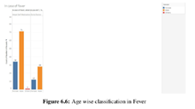

**6.2.4 Reasons for Self-Medication**

**Fever**

**Headache/Migraines**

The reasons for **SM** in fever and Headache/Migraines are mentioned as follows in order of their usage, the most chosen one being at the first.

**Cold and Cough**

**Skin Allergies\**

The reasons for **SM** in Cold/cough and Skin Allergies are mentioned as follows in order of their usage, the most chosen one being at the first.

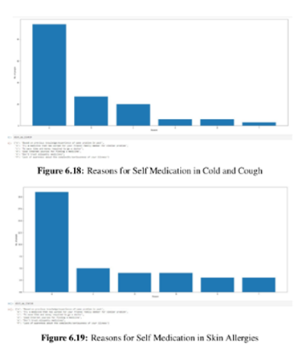

**Digestive Problem**

The reasons for **SM** in Digestive Problems are mentioned as follows in order of their usage, the most chosen one being at the first.

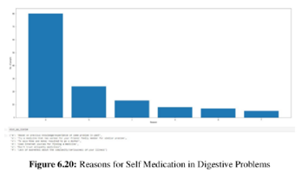

**CONCLUSION**

To understand that this research and study was to identify the ills of self-medication and help avoiding them from doing any harmful effects on the people, no direct support or criticism was directed to it. So is the case of Self-Medication and the sale/purchase of OTC. People should have a good knowledge of what kind of medical situation they are in and what should be the precautionary steps to be taken and what kind of drugs are to be prescribed. The use and practice of self-medication was found to be in abundance in India. But the drugs mentioned for the same were harmful ones and the same thing supports the fact that 4 percent of people had to go to doctor eventually. Here is the text extracted from the image: It was surprising enough to find that even in case of allergies 86 percent people opt for self-medication. Fever and headaches observed the maximum amount of self-medication. And taking medication based on previous knowledge was discovered to be the biggest factor for supporting self-medication. The online method of data collection proved to be successful and met the aim of gathering a variable data set from people of different regions. Such a system was beyond the scope of our project but has good scope for future research and development. Percent people opt for self-medication. Fever and headaches observed the maximum amount of self-medication. And taking medication based on previous knowledge was discovered to be the biggest factor for supporting self-medication. The online method of data collection proved to be successful and met the aim of gathering a variable data set from people of different regions. Such a system was beyond the scope of our project but has good scope for future research and development.

# References

|  |  |
| --- | --- |
| [1] | C. Bradley and A. Blenkinsopp, "Over the counter drugs. The future for self medication," BMJ (Clinical research ed.) vol. 312. |
| [2] | WHO, "The Role of the pharmacist in self-care and self-medication," 1998. |
| [3] | B. A. Sherazi, K. T. Mahmood, F. Amin, M. Zaka, M. Riaz and A. Javed, "SELF MEDICATION AND HEALTH INSURANCE COVERAGE IN MEXICO," *Journal of Pharmaceutical Sciences and Research ,* vol. 4, no. 3, p. 5, 2007. |
| [4] | "Guidelines for the regulatory assessment of medicinal products for use in self-medication," World Health Organization, 2000. |
| [5] | H. James, S. S. Handu, K. A. J. A. Khaja, S. Otoom and R. P. Sequeira, "Evaluation of the knowledge, attitude and practice of self-medication among first-year medical students," *international journal of the Kuwait University, Health Science Centre,* vol. 15, no. 4, 2006. |